AWARE
Vendor Portal Manual
Version Number 1


Table of Contents
About the Aware Vendor Portal 3
Vendor Portal Authentication 3
Initial Login 4
Accessing the Vendor Portal 6
Resetting your Password 7
Vendor Portal Dashboard 10
Vendor Information 11
System Message 11
Most Recent Activity 11
Items to Review 11
Items to Review (Draft Authorizations) 12
How to Accept a Draft Authorization 12
How to Reject a Draft Authorization 13
How to Request More Information from VR 15
Case Notes 16
Vendor Requested Payment 19
How to Resubmit a Rejected Payment Request 22
How to Create a Service Request 24
How to Search for an Authorization 27
Reports 28
Glossary 29
PERM to AWARE Cross functions – Appendix 30
PERM 30
Aware 30

About the Aware Vendor Portal
The Aware Vendor Portal system is a web-based service management application for Vocational Rehabilitation Vendors. The application provides a centralized portal for managing Service Authorizations, Case Notes, Service Requests and Payment Requests.
The Aware Vendor Portal Manual is a technical assistance guide on how to use the application and its features.

Vendor Portal Authentication
Only approved Vendor staff will be granted access to the Vendor Portal by Vocational Rehabilitation. Upon meeting Vocational Rehabilitation’s requirements, for approval, vendor staff will receive a Vendor Account Verification email from No.Reply@allianceenterprises.com with their username for the Vendor Portal. A temporary password will be sent from No.Reply@allianceenterprises.com in a separate email. Upon logging in, you will be prompted to verify your account and reset your password.
By using the Vendor Portal system, the VR Service Provider agrees to comply with and be bound by the terms and conditions of use published on the website.

Initial Login
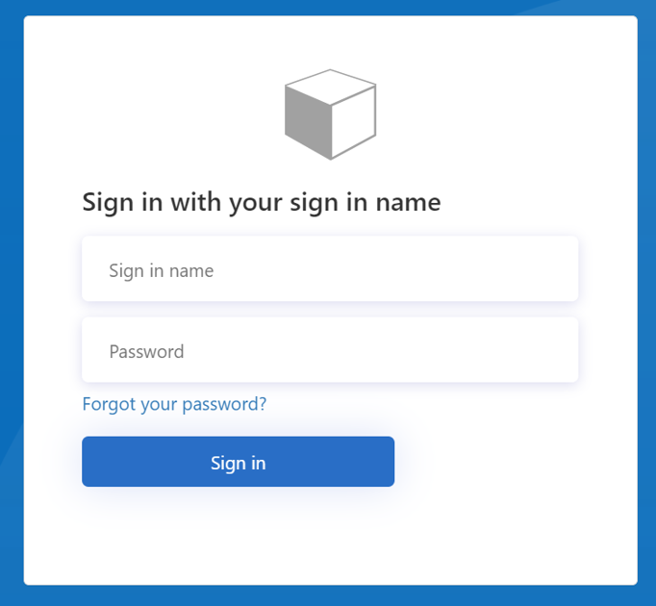
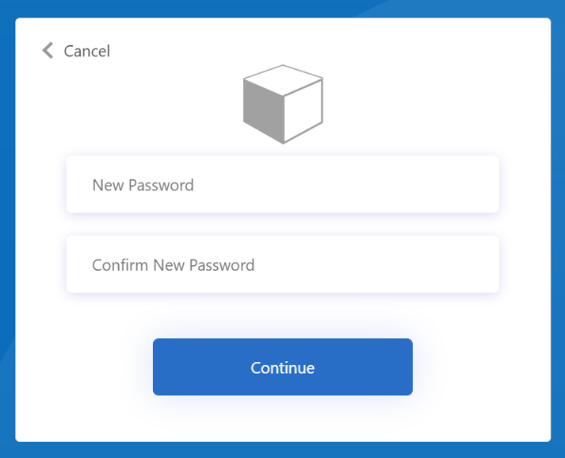
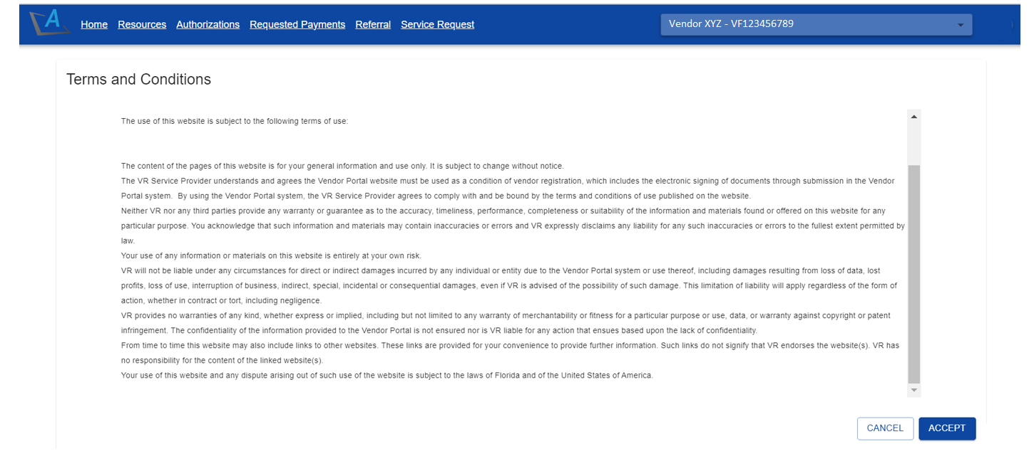
The step action table below reflects how to successfully move through the process of activating your Vendor Portal account.

 | Accessing the Vendor Portal
 | Step | Details
1 | Access the Vendor Portal | https://testfldvrvendor.awareportals.com
2 | Enter your Sign in Name | Email address registered with VR
3 | Enter your temporary password | Refer to Vendor Account Verification email from No.Reply@allianceenterprises.com
4 | Click on the Sign In button | You will be prompted to verify your account and reset your password
5 | Enter New Password in New Password Field
6 | Renter new password in the Confirm New Password Field
7 | Click on the Continue button
8 | Review the Terms and Conditions
9 | Click on the Accept button | If you continue to browse and use the Vendor Portal, you agree to comply with and be bound by the terms and conditions of use. If you disagree with any part of these terms and conditions, please do not use this website.

Resetting your Password

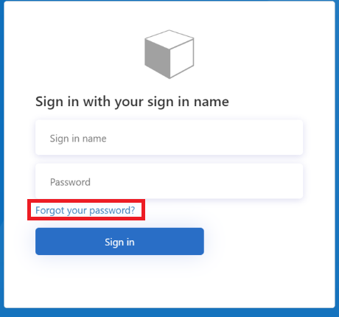
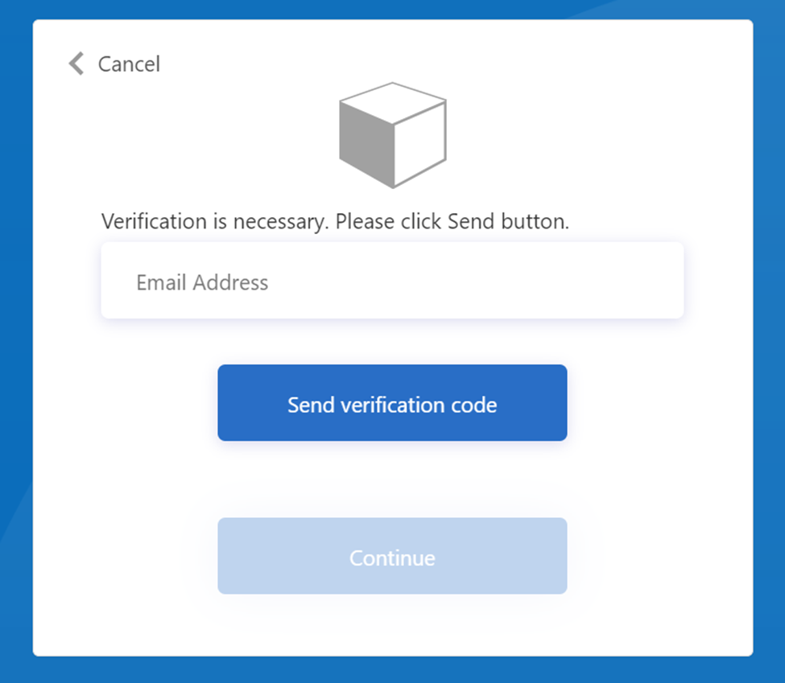
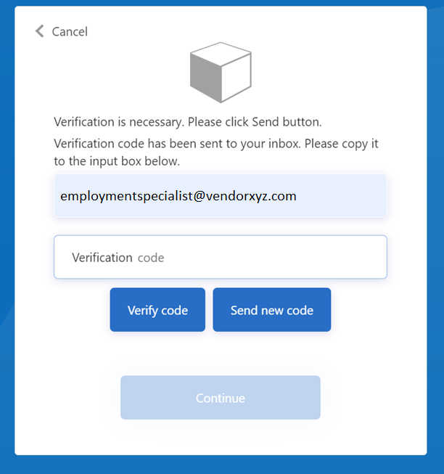
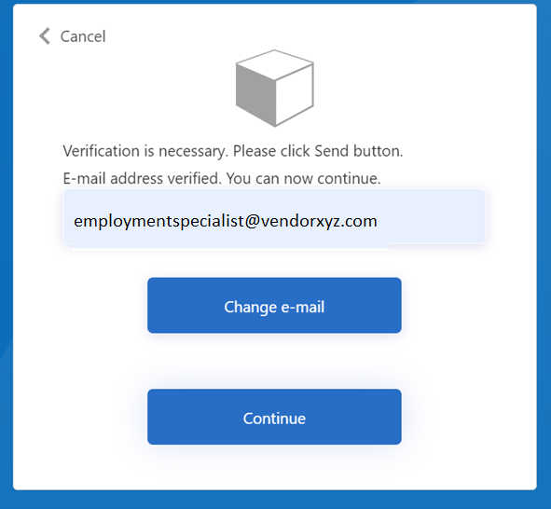
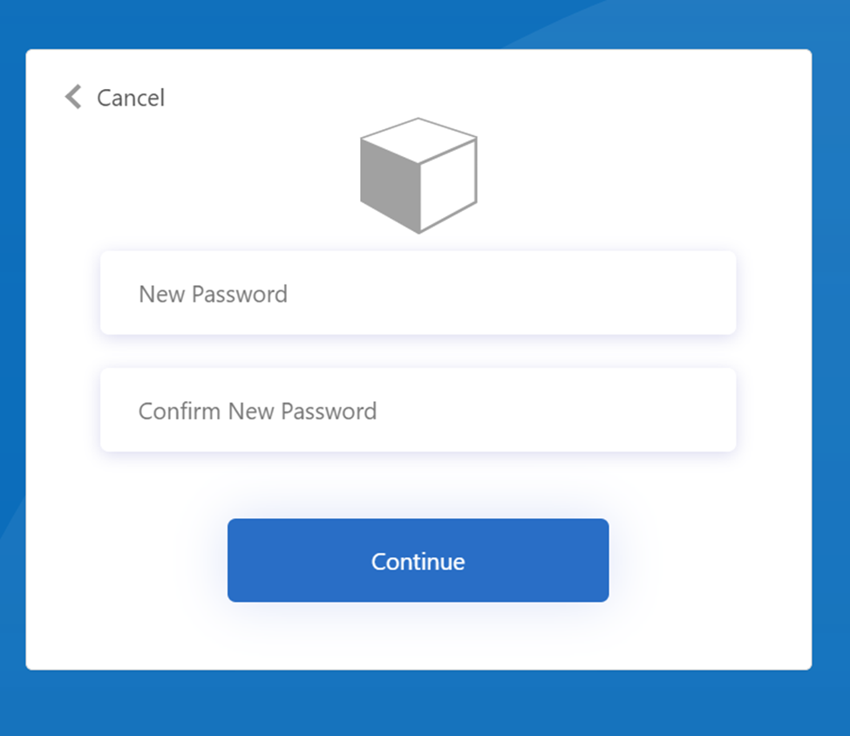
The step action table below reflects how to successfully move through the process of resetting your Vendor Portal account password.
 | Resetting your Password
 | Step | Details
1 | Access the Vendor Portal | https://testfldvrvendor.awareportals.com/
2 | Click on the Forgot your password? hyperlink
3 | Enter your email address | Vendor Portal Sign in Name
4 | Click on the Send Verification Code button
5 | Enter Verification Code from | Refer to FL DVR UAT account email verification code email from msonlineservicesteam@microsoftonline.com
6 | Click on the Verify code button | Verification code expires after 15 minutes
7 | Click on the Continue button | Do not change your email address. Access to the Vendor Portal is only permitted for email addresses registered with VR
8 | Enter New Password in New Password Field
9 | Renter new password in the Confirm New Password Field

Vendor Portal Dashboard
The Vendor Portal Dashboard allows the vendor to view Resources, Authorizations (Open authorizations, closed authorizations, authorizations eligible for payment, and draft authorizations), requested payments, referrals (Schools only), and service requests.
Data migration from PERM to AWARE will include open cases and related authorizations from the past five years (from 06/01/2018).
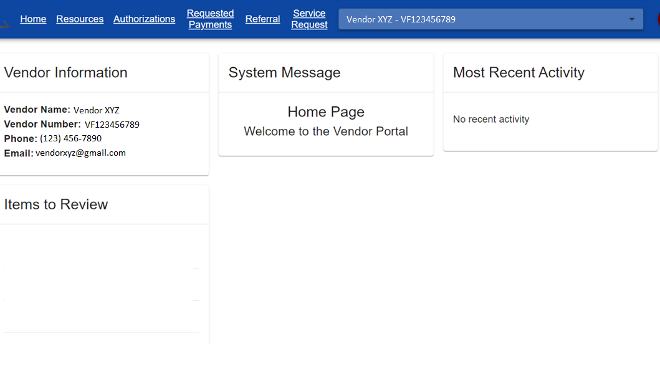

Vendor Information
This section displays the contact information of the Vendor Point of Contact for your agency. If the information in this section is incorrect, please contact Vendor Registration at VRVendors@vr.fldoe.org.

System Message
This is where VR can broadcast important system wide messages to all Vendor Portal users.

Most Recent Activity
This section shows the recent activity such as requested payments and service requests.

Items to Review
List of Draft Authorizations that have been sent to the vendor for review.

Items to Review (Draft Authorizations)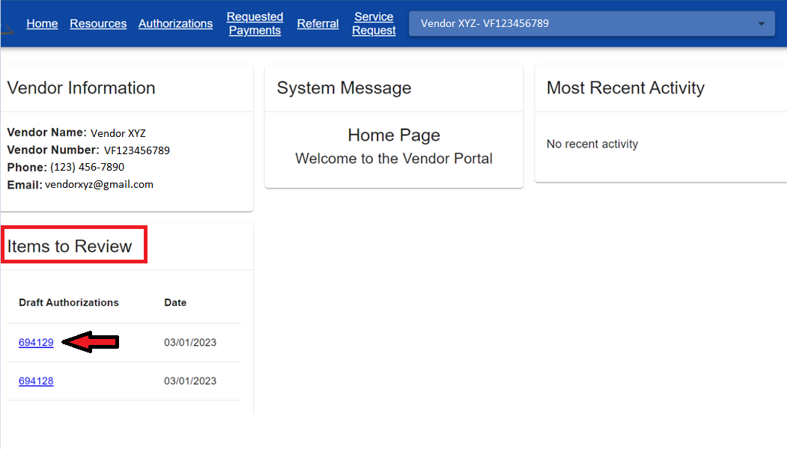

How to Accept a Draft Authorization
The Vendor will see Draft Authorizations that have been sent to their agency by VR (Vocational Rehabilitation) Staff and can accept the Draft Authorization if the Vendor agrees to work with the customer.
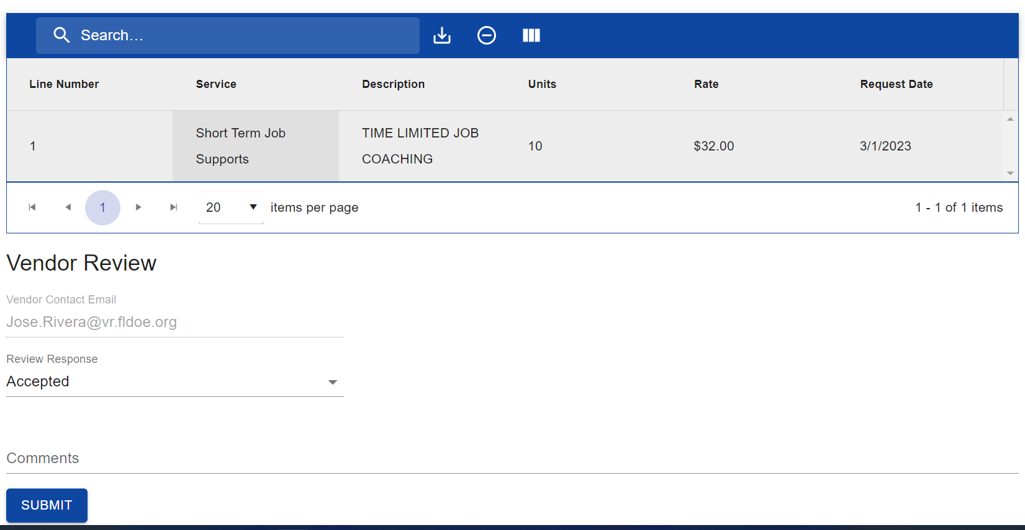
The step action table below reflects how to successfully move through the process. Once the Draft Authorization has been accepted, it is returned to VR electronically for issuance by VR. Once the Draft Authorization is issued, the Vendor may begin providing services.
 | From the Vendor Portal Home page
 | Step | Details
 | Accepting Draft Authorizations
1 | Log into the Vendor Portal | https://testfldvrvendor.awareportals.com/
2 | Under the Items to Review section on the Vendor Portal home page, click on the Draft Authorization hyperlink
3 | On the Draft Authorization Review screen, select Accepted from the Vendor Review dropdown
4 | Add a comment (optional)
5 | Click on the Submit button | The Draft Authorization will no longer display in the Items to Review section once the Draft Authorization has been Accepted

How to Reject a Draft Authorization
The Vendor will see Draft Authorizations that have been sent to their agency by VR Staff and can reject the Draft Authorization if the Vendor does not agree to work with the customer.

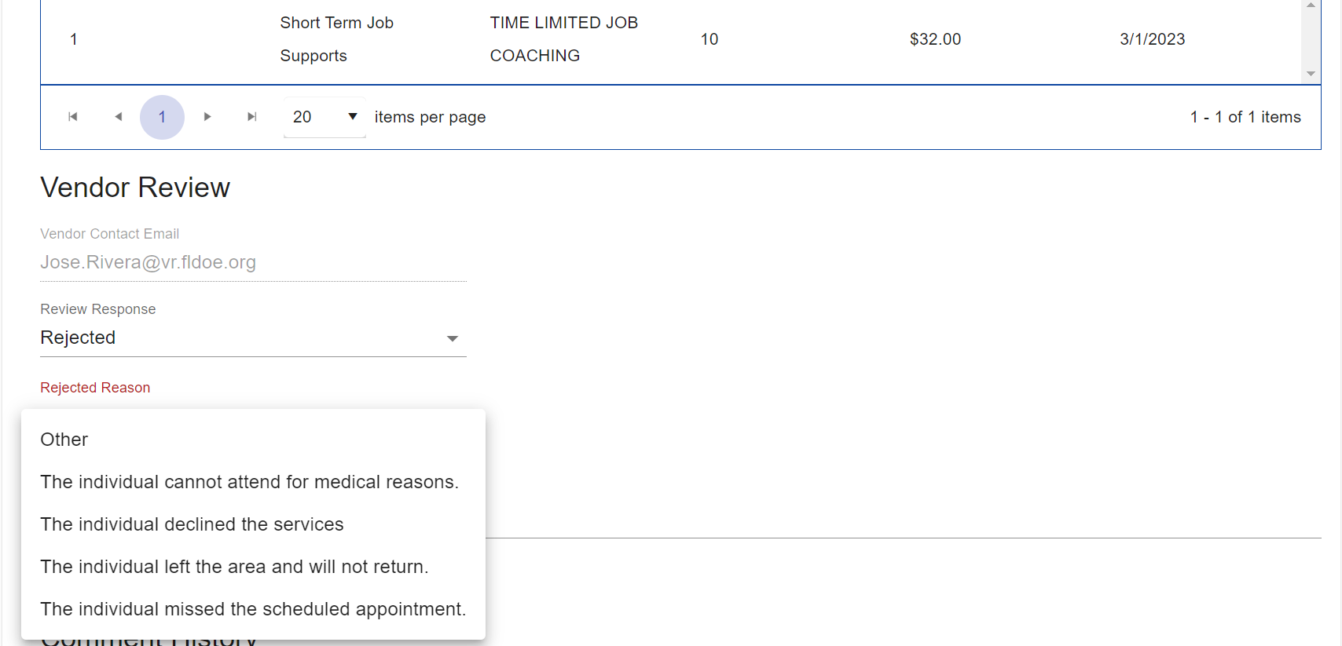
The step action table below only reflects how to successfully move through a process of rejecting a Draft Authorization. Once the Draft Authorization has been rejected, it is returned to VR electronically.
 | From the Vendor Portal Home page
 | Step | Details
 | Reject Draft Authorizations
1 | Log into the Vendor Portal | https://testfldvrvendor.awareportals.com/
2 | Under the Items to Review section on the Vendor Portal home page, click on the Draft Authorization hyperlink
3 | On the Draft Authorization Review screen, select Rejected from the Vendor Review dropdown
4 | Select a Rejected Reason from the dropdown selection | Rejection reason options:  - Other  - The Individual cannot attend for medical reasons  - The Individual declines the service  - The Individual left the area and will not return  - The Individual missed the scheduled appointment
5 | Add a comment (optional) | If Other is selected as a rejection reason, a comment is required.
6 | Click on the Submit button | The Draft Authorization will no longer display in the Items to Review section once the Draft Authorization has been rejected

How to Request More Information from VR
The Vendor will see Draft Authorizations that have been sent to their agency by VR Staff and can request more information if it is needed to work with the customer. The requested information should be documented in the comments section.
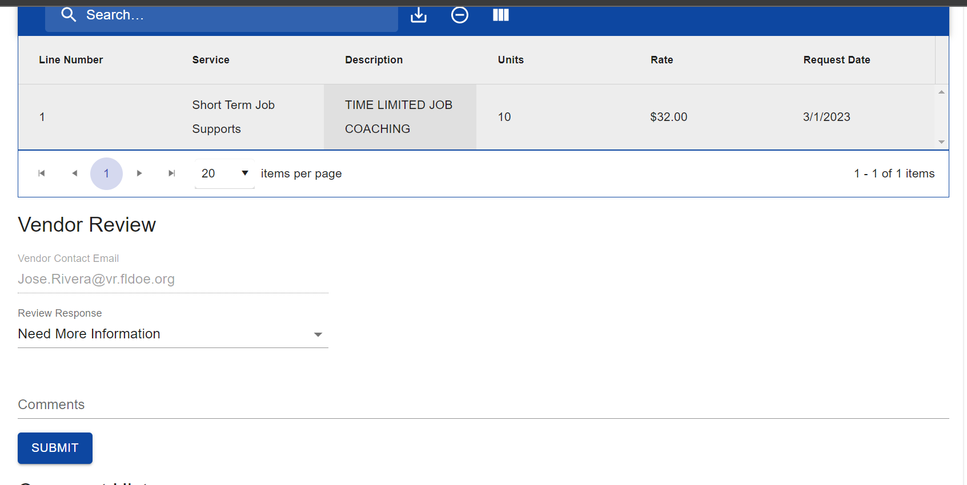
The step action table below only reflects how to successfully move through a process of requesting more information on the Draft Authorization. Once more information has been requested on the Draft Authorization, it is returned to VR electronically.

 | From the Vendor Portal Home page
 | Step | Details
 | Request More Information from VR
1 | Log into the Vendor Portal | https://testfldvrvendor.awareportals.com/
2 | Under the Items to Review section on the Vendor Portal home page, click on the Draft Authorization hyperlink
3 | On the Draft Authorization Review screen, select Need More Information from the Vendor Review dropdown
5 | Add a comment | A comment is required specifying what additional information is needed
6 | Click on the Submit button | The Draft Authorization will no longer display in the Items to Review section once more information has been requested on the Draft Authorization

Case Notes
Use the Case Note page to provide activity and documentation for a participant's case.
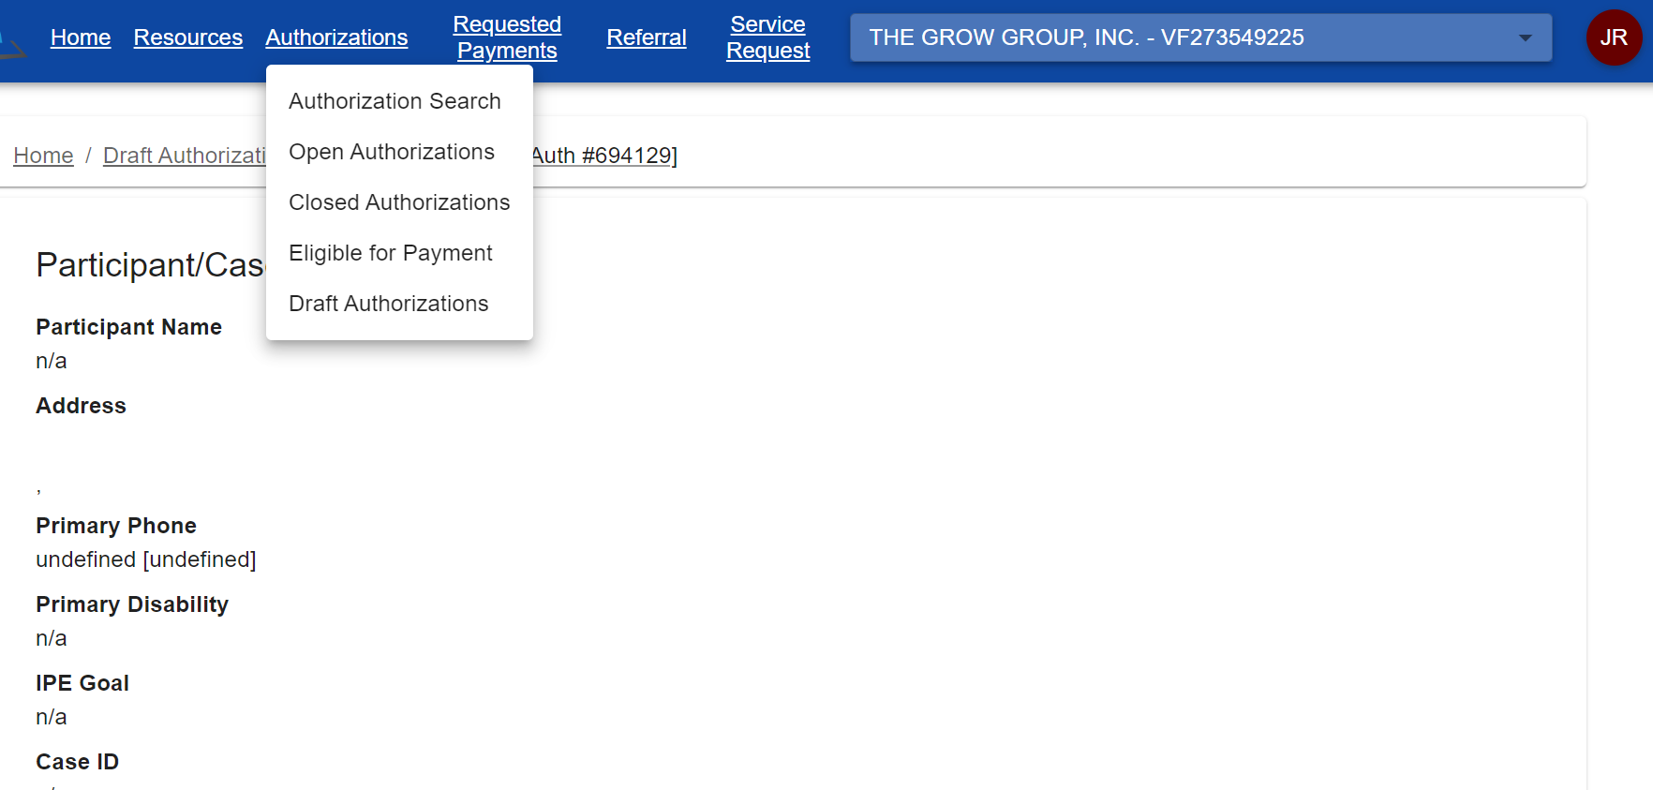
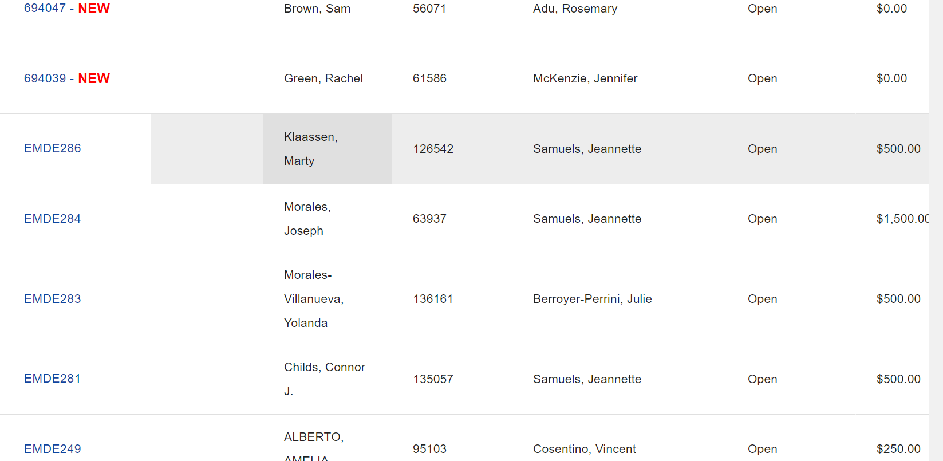
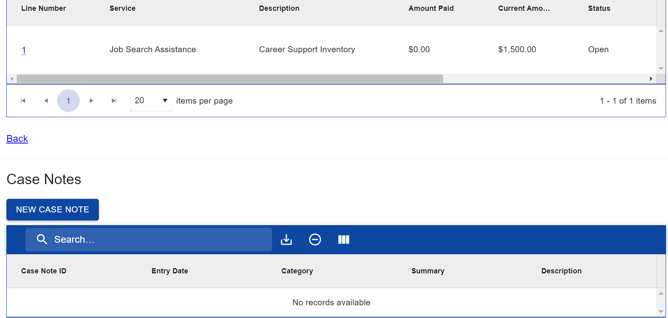
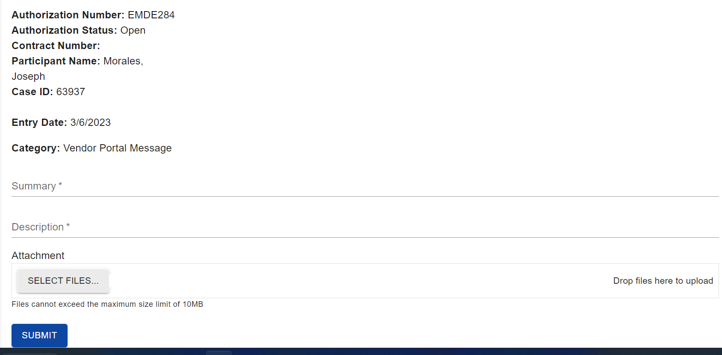
The step action table below reflects how to successfully move through a process of submitting a case note on an Authorization. See the Programmatic Operations Resource Guide (PORG) for details of what is required for documentation.
 | From the Vendor Portal Home page
 | Step | Details
 | Creating Case Note
1 | Log into the Vendor Portal | https://testfldvrvendor.awareportals.com/
2 | Click on the Authorization hyperlink located at the top of Vendor Portal home page
3 | Select Open Authorizations from the dropdown menu
4 | Click on the hyperlink for the desired Authorization number
5 | Click on the New Case note button
6 | Enter a Summary | A brief description or title for a case note.
7 | Enter a Description | A narrative record of the event or situation that will significantly impact a participant's case.
8 | Add an attachment | Attached files cannot exceed the maximum size limit of 10MB
9 | Click on the Submit button

Vendor Requested Payment
Once services are completed, a vendor requested payment can be submitted.
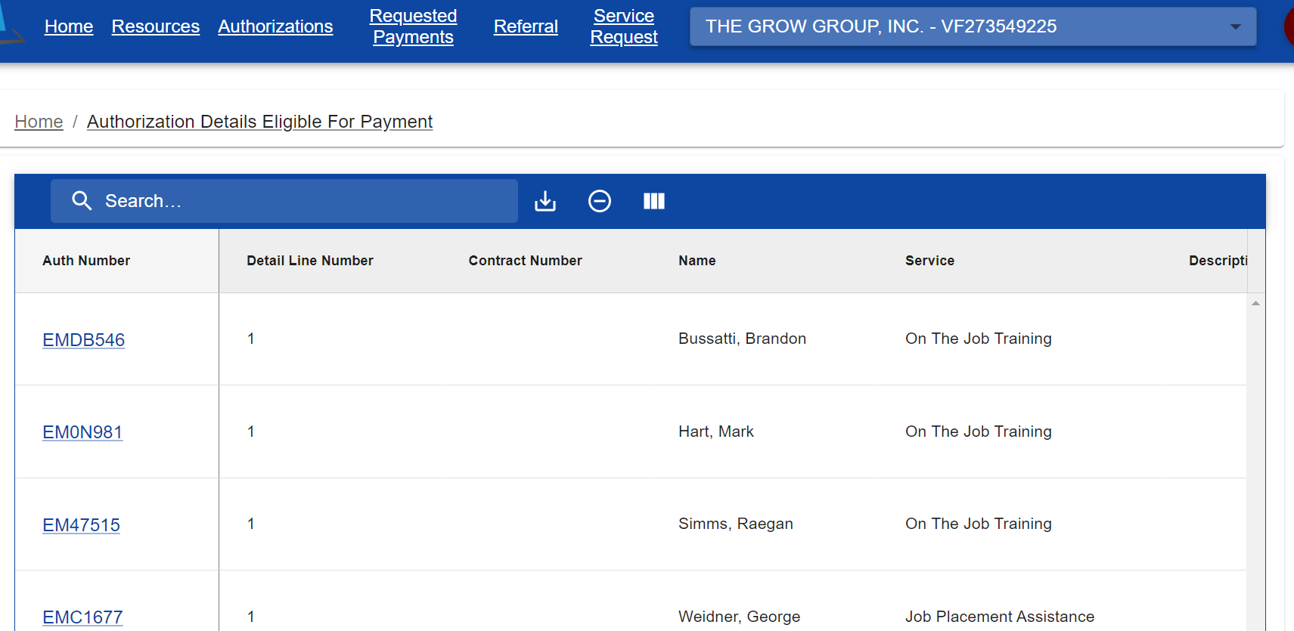
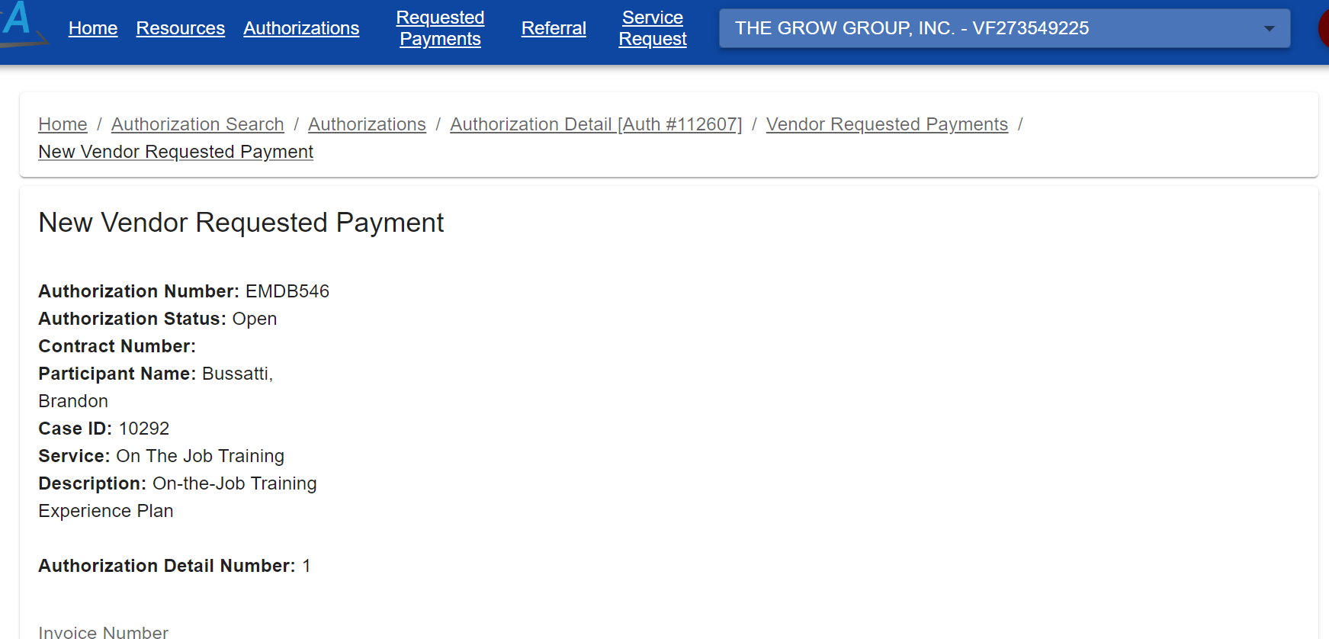
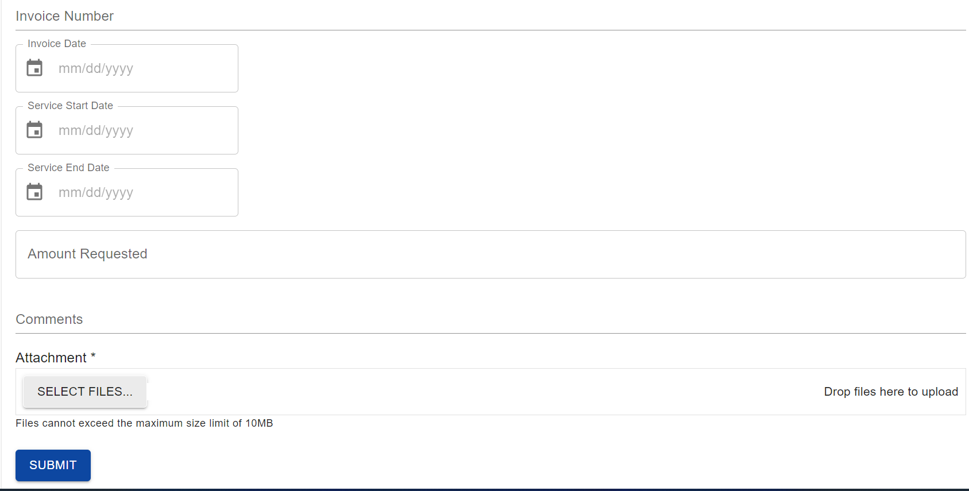
The step action table below only reflects how to successfully move through a process of requesting a payment on an Authorization.
 | From the Vendor Portal Dashboard
 | Step | Details
1 | Log into the Vendor Portal | https://testfldvrvendor.awareportals.com/
 | Creating a Payment Request
2 | Select the Authorizations hyperlink located on the top Menu on the Vendor Portal page
3 | Select Eligible for Payment | Authorizations that are eligible for payment are collectively displayed via the payment grid.
4 | Select the desired Authorization Number hyperlink to navigate to Authorization detail page
5 | On the Authorization detail grid, scroll the bar to the end, the Request Payment button is displayed on Actions column.
6 | On New Vendor Requested Payment screen click on Submit located at the bottom of the screen
7 | Enter an Invoice Number | The vendor must create a unique invoice number for each the authorization payment request item
8 | Enter an Invoice Date | The invoice date must be when the vendor enters a new request for Payment.
9 | Enter a Service Start Date | Date the Authorization was issued
10 | Enter a Service End Date | Please refer to PORGs, for additional guidance.
11 | Enter the Amount Requested | The requested amount must match the approved authorization.
12 | Add an attachment | Attached files cannot exceed the maximum size limit of 10MB
13 | Enter a comment (optional) | A narrative description for a vendor requested payment.
14 | Click on the Submit button | An error message will occur in the application if you have done something incorrectly. Follow the prompts on the screen to correct the error.

How to Resubmit a Rejected Payment Request
Rejected Vendor requested payments can be corrected and resubmitted for review.
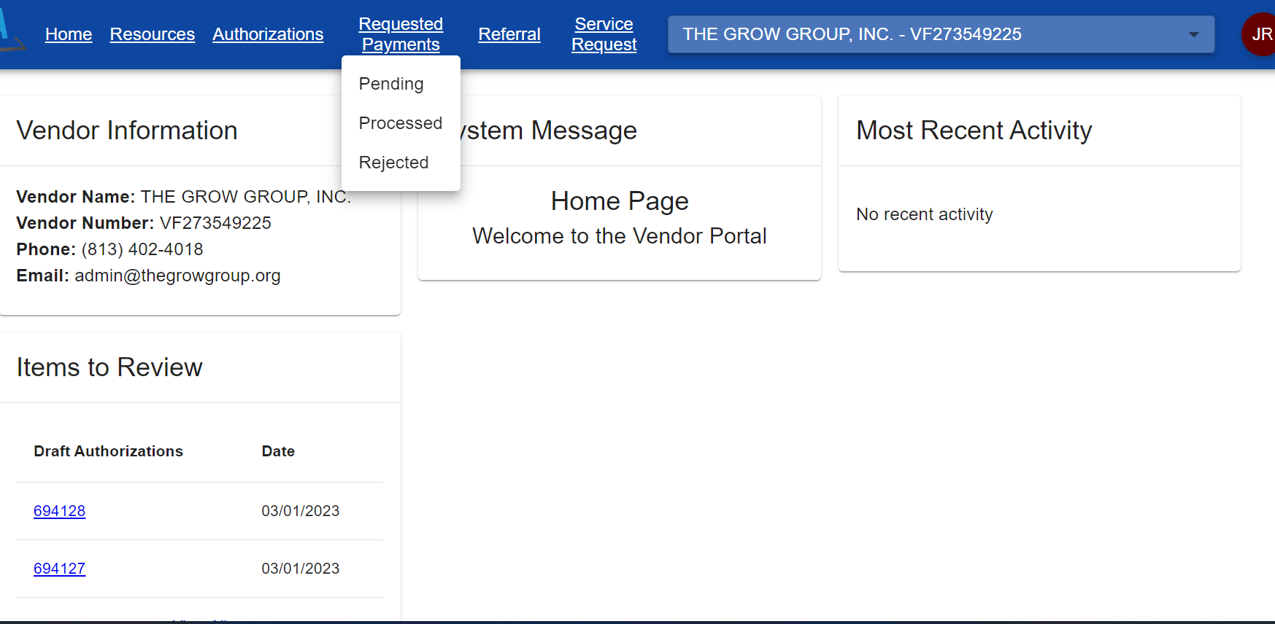
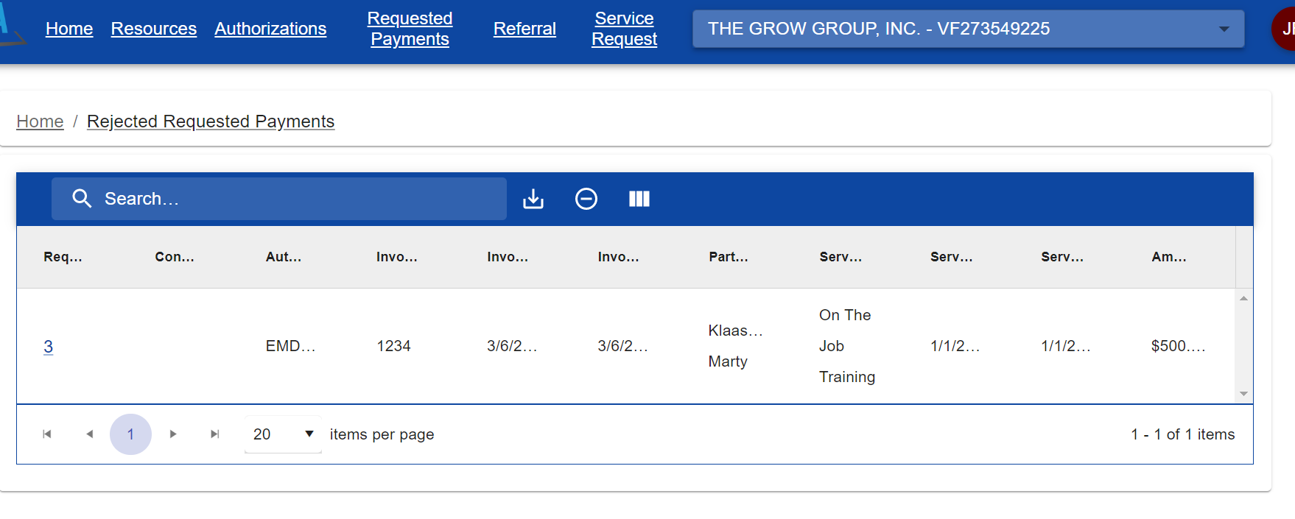

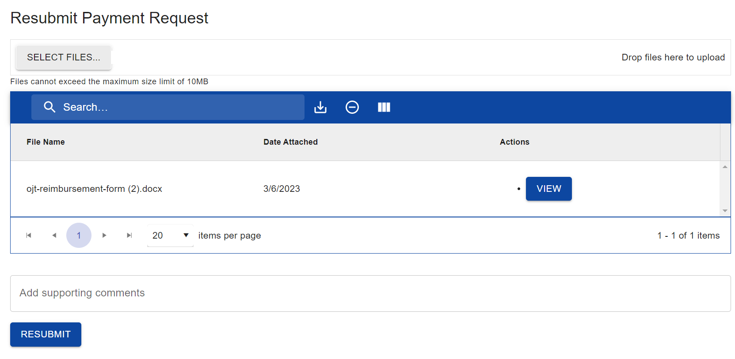

The step action table below only reflects how to successfully move through a process. An error message will occur in the application if you have done something incorrectly. Follow the prompts on the screen to correct the error.

 | From the Vendor Portal Dashboard
 | Step | Details
1 | Log into the Vendor Portal | https://testfldvrvendor.awareportals.com/
 | Resubmitting a Rejected Payment Request
2 | Select Requested payments menu located at the top of the menu.
3 | Select Rejected in the menu | Reject Requested Payment grid will display
4 | Select desired Requested Payment ID hyperlink
5 | Enter supporting comments in Add Supporting Comments section
6 | Click on the resubmit button | A warning message is displayed indicating the Vendor Requested Payment submitted

How to Create a Service Request
Service Requests can be created to add a Service to an Open Authorization
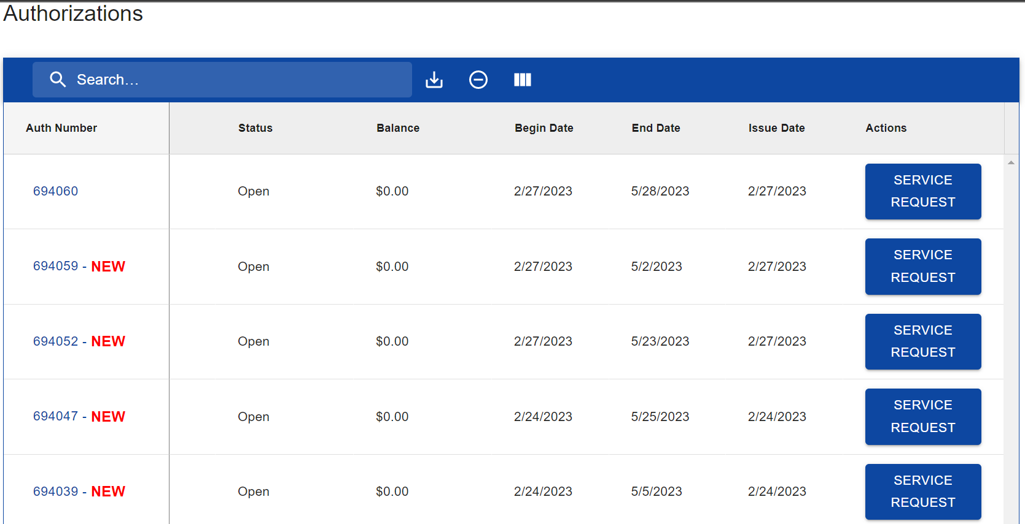
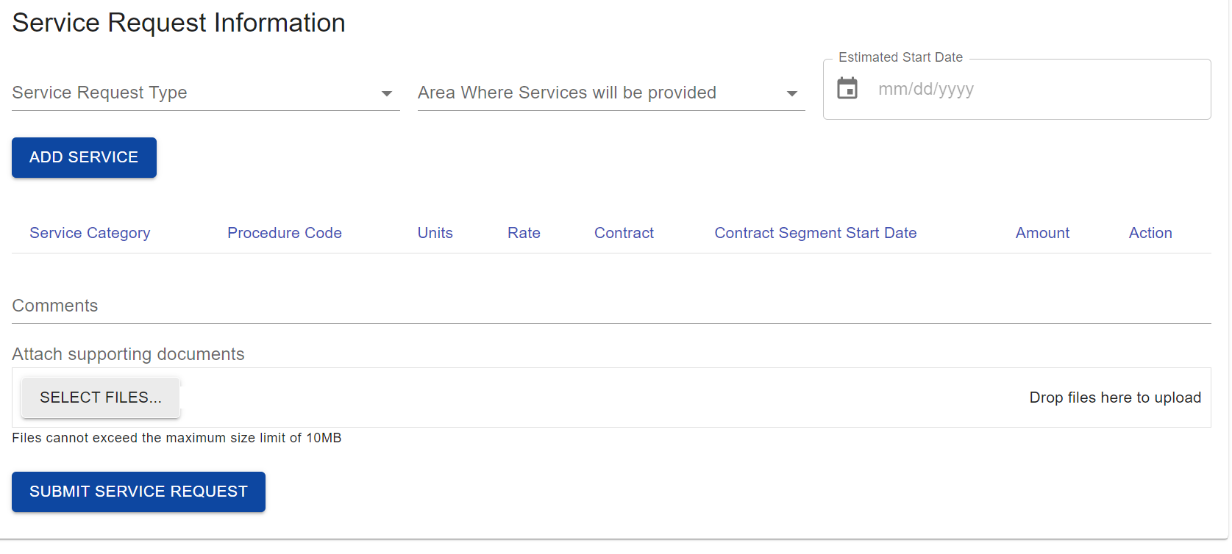
The step action table below only reflects how to successfully move through a process of adding a Service Request on an open Authorization.
 | From the Vendor Portal Dashboard
 | Step | Details
1 | Log into the Vendor Portal | https://testfldvrvendor.awareportals.com/
 | Create a Service Request
2 | Select Authorizations hyperlink located on the top Menu on the Vendor Portal page
3 | Select Open Authorization on the Menu | All the Open Authorizations are displayed
4 | Move the scroll bar located at the bottom of the grid to the end (right)
5 | Click on Service request button to navigate to Service Request screen
6 | On the Service Request screen. select Service Request Type from dropdown
7 | Select Area Where Services will be Provided from dropdown
8 | Click on the Add Service Button
9 | Select the Service Category and click on Search
10 | The list of Procedure Codes linked to Service Category are displayed.
11 | Select the Procedure Code and click on the Add button
12 | Enter Unit(s)
13 | Enter Rate
14 | Click on Select Files, a window is open that allows you to upload a document or attachment. | Attached files cannot exceed the maximum size limit of 10MB
15 | Click on Submit Service Request | An error message will occur in the application if you have done something incorrectly. Follow the prompts on the screen to correct the error.

How to Search for an Authorization
Search for a customer’s Authorization that has been sent to your agency.
The step action table below only reflects how to successfully move search for Authorizations in various statuses.

 | From the Vendor Portal Dashboard
 | Step | Details
1 | Log into the Vendor Portal | https://testfldvrvendor.awareportals.com/
 | Search for Authorizations
2 | Select Authorizations hyperlink located on the top Menu on the Vendor Portal page | The Authorizations display the following options-  - Authorization Search  - Open Authorizations  - Closed Authorizations  - Eligible for Payment  - Draft Authorizations
3 | On Authorization Menu, Select 'Authorization Search' | Authorization Search screen is displayed
4 | The Select status dropdown is defaulted with 'Open' | Select the Select Status dropdown to verify the following options-  - (All)  - Open  - Closed  - Cancelled
5 | Click on Find Authorization

Reports
To be determined

Glossary

Draft Authorization – A request for service from VR staff to vendor
Open Authorization – A Service Authorization that has been issued to vendor, in open status
Participant – An individual with a documented disability, receiving vocational rehabilitation services in an eligible or potentially eligible status.
Service Authorizations – Electronic requests used to request goods and services for VR participants (previously known as “referrals”)
Requested Payment – The amount a vendor requested payment for a specific authorization item.
Case ID – A unique number assigned to a specific participant
Invoice Number – A unique identifier assigned by the vendor that is directly tied to a payment request for approved authorizations.
Authorization Begin Date – The beginning date of an authorization and the earliest date on which services authorized can occur.
Authorization end date – The date when services are expected to be completed.

PERM to AWARE Cross functions – Appendix

PERM | Aware
VR Staff create a referral for Employment  Services, Supported Employment Services, Career Camp and/or on the job training | VR Staff create a Draft Authorization for services
Provider reviews referral: Accept/reject/Request more information | Vendor reviews Authorization: Accept/reject/Request more information
Provider begins providing requested services listed on the referral for accepted referrals | VR staff issue an open Authorization for Services if the draft Authorization was accepted.
Provider creates and submits Monthly Progress Reports (MPRs) each month for each customer they are actively serving | Provider begins providing requested services listed on the Authorization once the Authorization has been issued.
VR Staff review and approve MPRs | Provider creates and submit case notes documenting progress and attaches any supporting documentation
Provider creates and submits Approval Notice (NOAs) | Provider requests Payment by submitting report/supporting documentation and completed invoice
VR Staff review and approve NOAs | VR staff reviews vendor submitted report/supporting documentation & invoice
Provider creates and submits Service Invoice | VR Staff creates and process authorization and sends Authorization to Financial Payment

